**מעבדה 2 את"מ:  
  
מגישים:  
 אורי מלכא- 314862996   
אלן ציפין- 313206062  
תרגיל 1:**  
;

; hello4.asm - Conditional response.

;

.MODEL SMALL

.STACK 100h

.DATA

TimePrompt DB 'Is it 12 after noon (y/n)?',13,10,':$'

GoodAfternoonMessage DB 13,10

DB 'Good afternoon, world!',13,10,'$'

GoodMorningMessage DB 13,10

DB 'Good morning, world!',13,10,'$'

ErrorMassage DB,13,10

DB 'Input Error',13,10,'$'

;

;

.CODE

ProgStart:

MOV AX,@DATA ; DS can be written to only through a register

MOV DS,AX ; Set DS to point to data segment

MOV AH,9 ; Set print option for int 21h

MOV DX,OFFSET TimePrompt ; Set DS:DX to point to TimePrompt

INT 21h ; Print TimePrompt

MOV AH,1 ; DOS get character function #

INT 21h ; Get a single character from keyboard

CMP AL,'y' ; AL has input. Compare with 'y'

JE IsAfternoon ; If AL = 'y' then go to IsAfternoon

CMP AL,'Y' ; Compare with 'Y'

JE IsAfternoon ; If AL = 'Y' then go to IsAfternoon

CMP AL,'n' ; AL has input. Compare with 'n'

JE IsMorning ; If AL = 'n' then go to IsMorning

CMP AL,'N' ; Compare with 'N'

JE IsMorning ; If AL = 'N' then go to IsMorning

ErrorMassageLabel:

MOV DX, OFFSET ErrorMassage ; print error message

JMP DisplayGreeting

IsMorning:

MOV DX,OFFSET GoodMorningMessage ; Point display message to morning

JMP DisplayGreeting ; Avoid following code

IsAfternoon:

MOV DX,OFFSET GoodAfternoonMessage ; Point display message to afternoon

DisplayGreeting:

MOV AH,9 ; Set print option for int 21h

INT 21h ; Print chosen message

MOV AH,4Ch ; Set terminate option for int 21h

INT 21h ; Return to DOS (terminate program)

END ProgStart

פלטים:  
 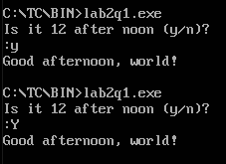  
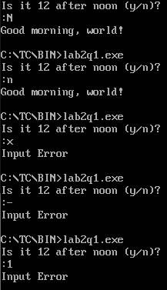  
  
  
  
  
  
  
  
  
  
  
  
  
  
  
  
  
  
תרגיל 2:  
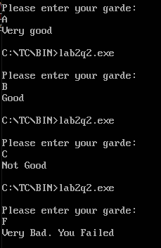  
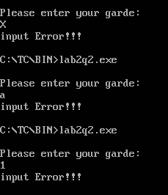

;

; Lab2q2.asm - Conditional response.

;

.MODEL SMALL

.STACK 100h

.DATA

AskForGrade DB 13,10

DB 'Please enter your grade:',13,10,'$'

GradeAmessage DB 13,10

DB 'Very good',13,10,'$'

GradeBmessage DB 13,10

DB 'Good',13,10,'$'

GradeCmessage DB 13,10

DB 'Not Good',13,10,'$'

GradeFmessage DB 13,10

DB 'Very Bad. You Failed',13,10,'$'

ErrorMessage DB 13,10

DB 'input Error!!!',10,13,'$'

;

;

.CODE

ProgStart:

MOV AX,@DATA ; DS can be written to only through a register

MOV DS,AX ; Set DS to point to data segment

MOV AH,9 ; Set print option for int 21h

MOV DX,OFFSET AskForGrade ; Ask for grade

INT 21h ; Print AskForGrade

MOV AH,1 ; DOS get character function #

INT 21h ; Get a single character from keyboard

;

CMP AL,'A'

JE GradeA

CMP AL,'B'

JE GradeB

CMP AL,'C'

JE GradeC

CMP AL,'F'

JE GradeF

Error:

MOV DX,OFFSET ErrorMessage

JMP DisplayGreeting

GradeA:

MOV DX,OFFSET GradeAmessage ;point display message for GradeA

JMP DisplayGreeting

GradeB:

MOV DX,OFFSET GradeBmessage ;point display message for GradeB

JMP DisplayGreeting

GradeC:

MOV DX,OFFSET GradeCmessage ;point display message for GradeC

JMP DisplayGreeting

GradeF:

MOV DX,OFFSET GradeFmessage ;point display message for GradeF

JMP DisplayGreeting

DisplayGreeting:

MOV AH,9 ; Set print option for int 21h

INT 21h ; Print chosen message

MOV AH,4Ch ; Set terminate option for int 21h

INT 21h ; Return to DOS (terminate program)

END ProgStart